**Cryptoverse: A Cryptocurrency Dashboard**

**Ideation Phase**

**Define the Problem Statements**

|  |  |
| --- | --- |
| Date | 10 March 2025 |
| Team ID | SWTID1741258148149965 |
| Project Name | Cryptoverse: A Cryptocurrency Dashboard |
| Maximum Marks | 2 Marks |

**Customer Problem Statement Template:**

With the increasing adoption of cryptocurrencies, users require a reliable platform to track real-time data, analyze trends, and make informed investment decisions. However, existing solutions often lack a seamless user experience, comprehensive data visualization, and efficient real-time updates.

**Cryptoverse** aims to bridge this gap by providing an interactive web application that allows users to explore various cryptocurrencies, visualize price trends using charts, and access key market insights in real time. The platform integrates APIs for up-to-date information, utilizes Redux for efficient state management, and presents data using user-friendly UI components from Ant Design.

**Example:**

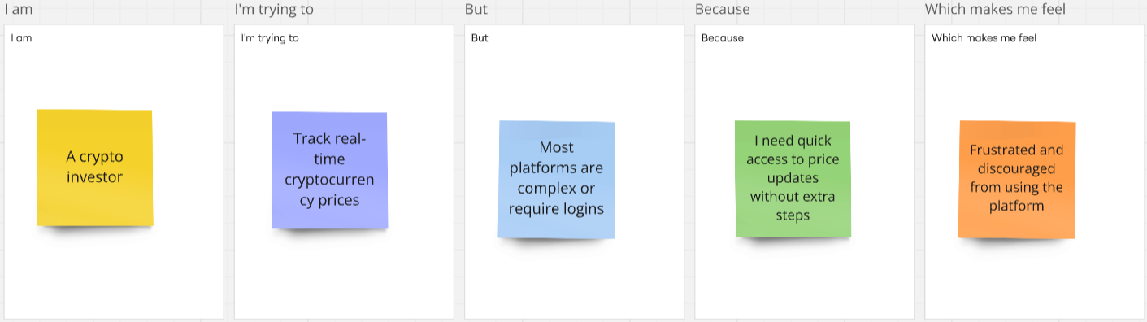

|  |  |  |  |  |  |
| --- | --- | --- | --- | --- | --- |
| Problem Statement (PS) | I am (Customer) | I’m trying to | But | Because | Which makes me feel |
| PS-1 | A crypto investor | Track real-time cryptocurrency prices | Most platforms are complex or require logins | I need quick access to price updates without extra steps | Frustrated and discouraged from using the platform |
| PS-2 | A beginner in crypto | Understand market trends easily | The available dashboards are too technical | I need a simple, visually appealing interface to analyze data | Overwhelmed and unsure about making decisions |
| PS-3 | A day trader | Monitor price fluctuations and make quick decisions | The API data is slow or not updating in real-time | I need instant updates to react to market changes quickly | Anxious and unable to trade efficiently |
| PS-4 | A user tracking multiple coins | Compare different cryptocurrencies in one place | Most platforms focus on a few major coins | I want a customizable dashboard that lets me track my preferred assets | Limited and forced to use multiple apps |